Grazioso Salvere Dashboard
A simple dashboard to filter potential rescue animals from Austin Animal Center’s database.

Description
This web dashboard takes Austin Animal Center’s outcome database and sorts it into a filterable, easy to understand data table. This data table is also connected to an onsite map and pie chart, both of which update to reflect the filters.

Getting Started

Dependencies
- This dashboard uses a database built in MongoDB.
  - MongoDB’s flexible system was integral for AAC’s database to function properly, as not every item is inputted uniformly.
  - MongoDB’s official Python driver pyMongo, was necessary for the CRUD_Python_Module module that this dashboard was built on. The CRUD functionality in pyMongo made the CRUD module simple to implement and use, where it could have been more difficult.
  - The python module and the dashboard interface rely heavily on MongoDB’s authentication system, which simplify role-based security and keep the database safe from unauthorized users.
- The dashboard was built using the Dash framework.
  - Using callbacks, Dash allows interactive data elements, such as the map and pie chart, to update in real time to user input. This allows the dashboard to have more complex functions than a simple data table.
- The pie chart was made with the plotly library.
- The re library allowed usage of regular expressions for my queries. https://docs.python.org/3/library/re.html

Usage
Running the program will load the default page, a data frame organizing the entirety of AAC’s outcome database. At the top of the page is the title, my attribution, and Grazioso Salvare’s logo.
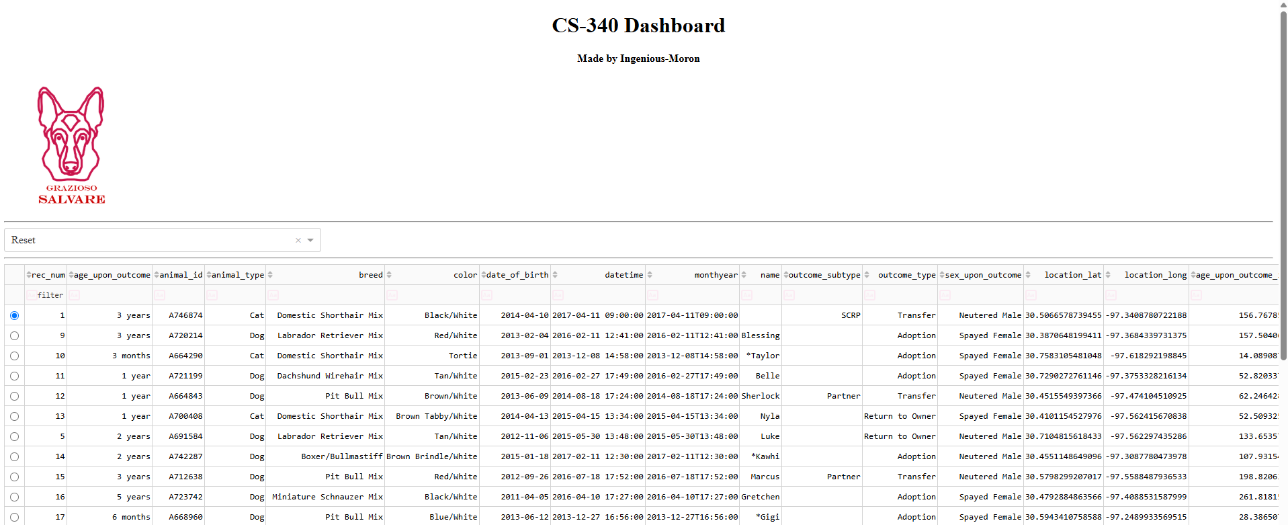

Below the data frame is the pie chart and map.
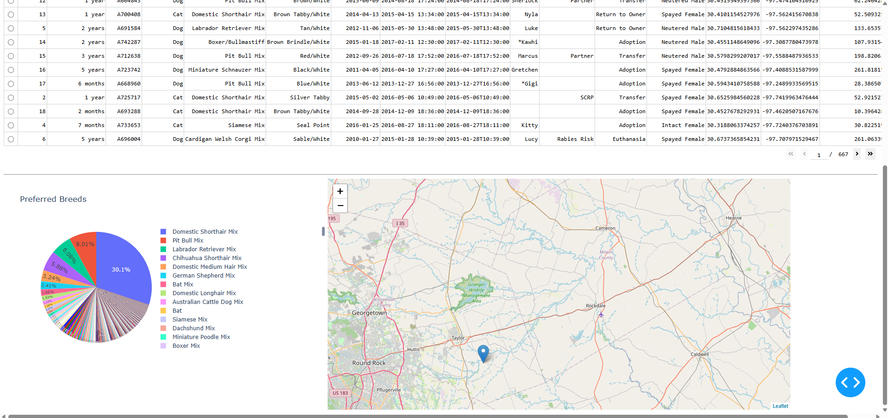
Selecting a specific animal updates the map. Hovering over the point will reveal the breed in a popup. Clicking on the point will show the animal’s name.
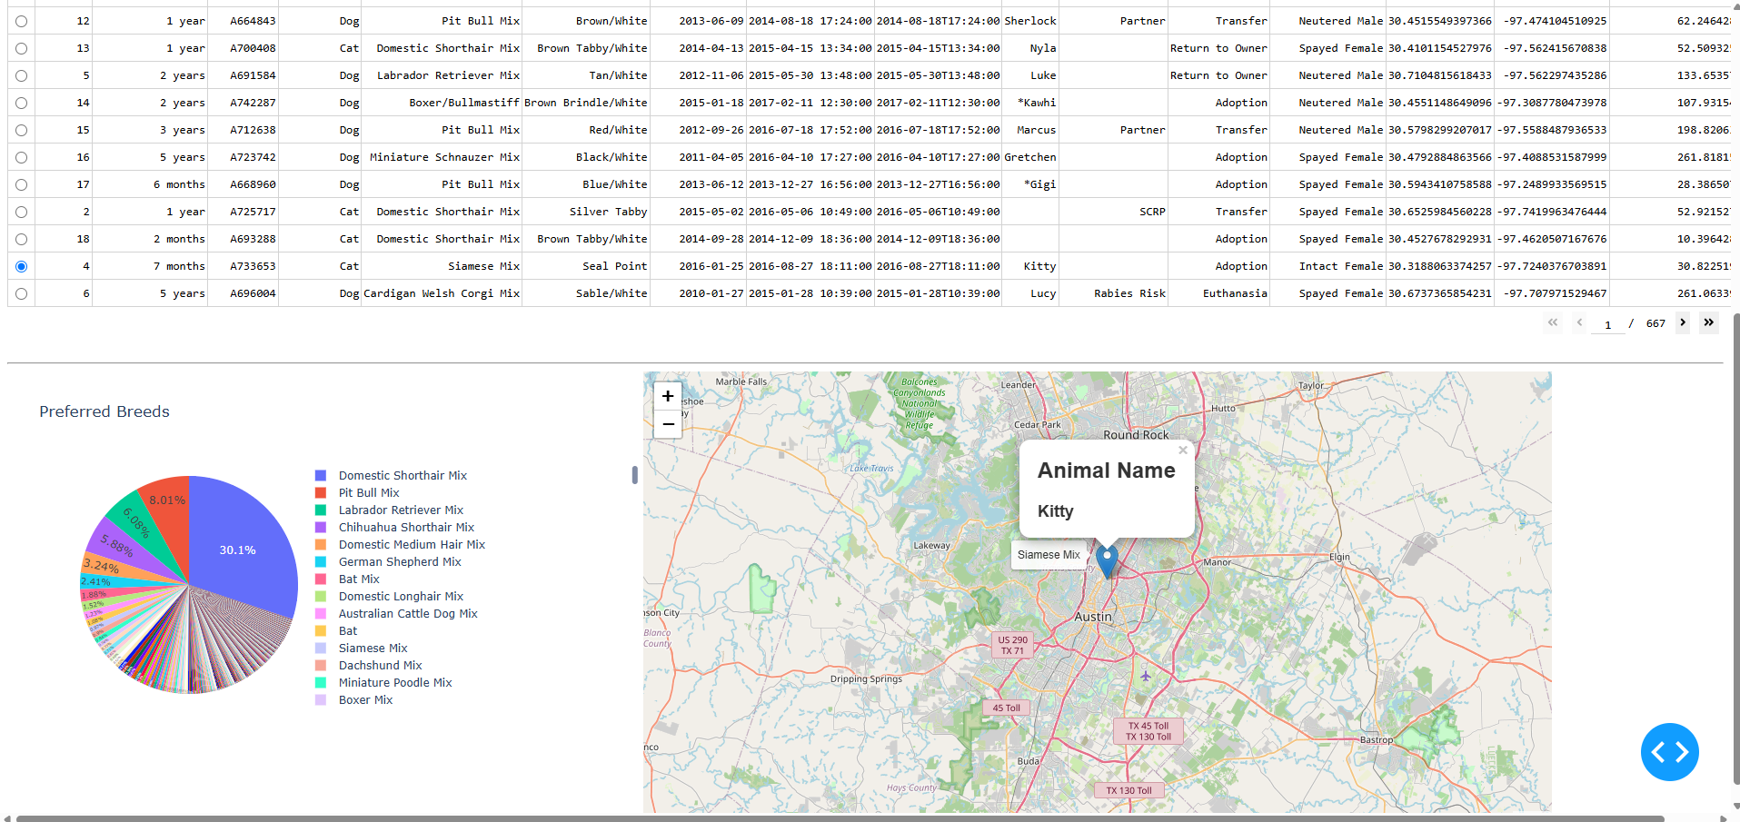

The drop down menu allows the user to select for different types of rescue animals.
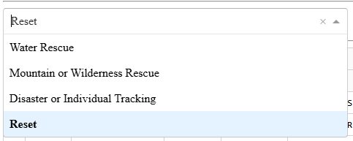
Selecting any type will update the data frame to reflect it.
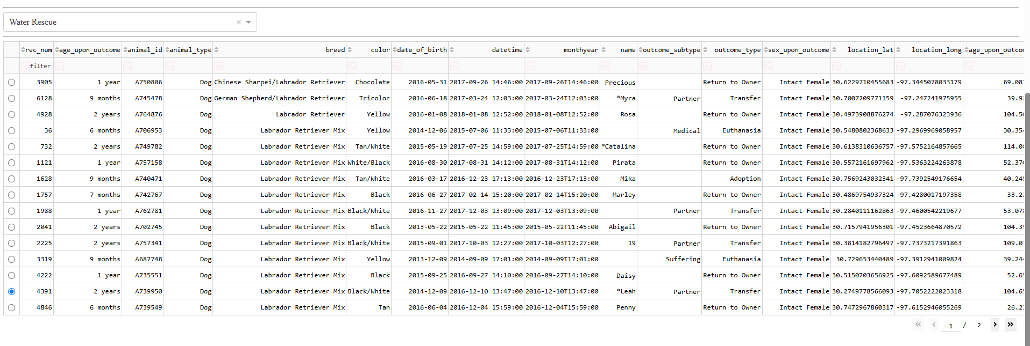
The pie chart will also update to show breed makeup per rescue animal type.
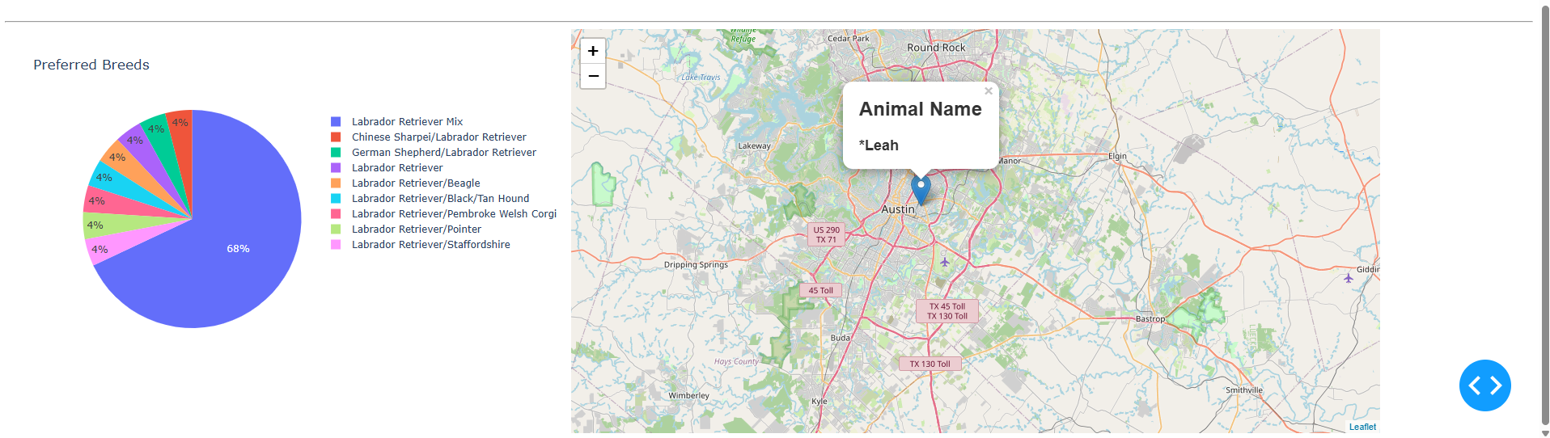

Creation

Process
This dashboard was created on top of my previous Python_CRUD_Module and relies heavily on it. Knowing the CRUD functionality I encoded as well as MongoDB’s underlying functionality drove my use of regex for the filter queries. Much of the dashboard was a template provided to me, but following the Dash and Plotly documentation allowed me to fully implement the data frame, map, pie chart, and drop-down menu. Development was done in stages, with the data frame and map being implemented first, then the logo, pie chart and filter options.

Difficulties
I had relatively few difficulties, though I did struggle at first to figure out how to handle the lack of consistent data for filtering. Going over Mastering Mongo DB 6.x again reminded me of smart querying options and gave me the idea to use regex.
I also struggled to format the pie chart exactly how I wanted it at first. When I first loaded the pie chart, the way it wanted to label every slice forced the chart to me small so a bunch of arms can point to it. Going over plotly’s documentation again allowed me to configure it to the point that it behaved nicely.
I also had several minor errors, particularly in the callbacks not receiving data properly because of improper inputs or things being in the wrong format for the callbacks to read. Googling the error codes and looking at stack exchange gave me a lot of ideas of how to fix my errors.

